OPEN SOURCE TECHNOLOGIES
(01CE0618)
Lab Manual

Name: vasu Vardhan kumar Bhukya
Enrolment No: 92410103052
Class: EC2
Batch: B

INDEX

Lab | Program | Date | Marks | Signature
1. | Explore GitHub/GitLab for open-source projects with different licenses
2. | Setup Git and explore commands related to Version  Control System (VCS)
3. | Create a GitHub/GitLab repository and upload sample code
4. | Use npm / yarn / pip to install and manage packages
5. | Deploy a simple application using Nginx / Apache
6. | Setup Nginx to handle proxy requests and load balancing
7. | Develop a Laravel / Django based web application
8. | Use pytest to test a Python application
9. | Use Selenium to create browser-based tests
10. | Use Postman to test a sample API
11. | Use OWASP ZAP to check security integrity
12. | Modify any open-source desktop application
 | Contribute to any web-based open-source project
 | Use source code of an open-source web application and deploy it locally

Experiment 1
AIM: Explore GitHub/GitLab for open-source projects with different licenses
- List of GitHub Licenses

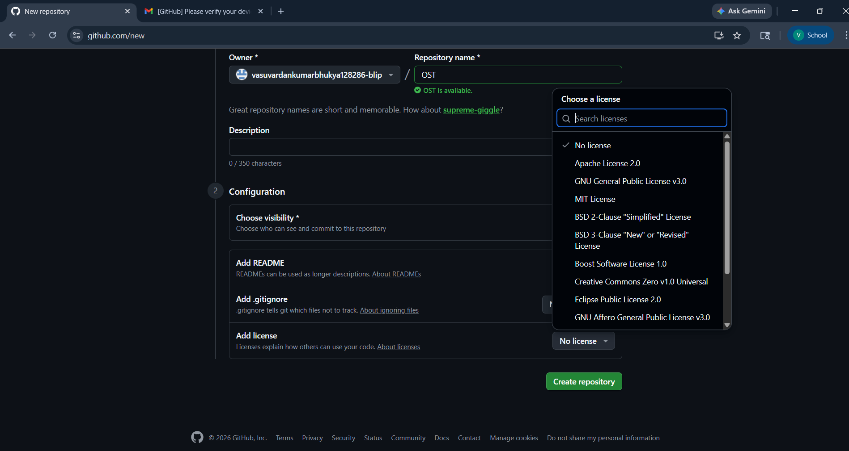
- Licenses and Short Description Table

License | Type | Short Description | Best Used For
o License | Proprietary | o one can legally use,  modify, or distribute your code | Private or restricted projects
MIT License | Permissive | Free use, modification, distribution (even commercial) with attribution | Student projects, open-source libraries
Apache License  2.0 | Permissive | Įike MIT + patent protection | Professional fi enterprise projects
GU GPL v3.0 | Strong Copyleft | Modified code must remain open-source | Enforcing open- source sharing
GU GPL v2.0 | Strong Copyleft | Same as GPĮv3 but without patent rules | Įegacy open-source projects
GU LGPL v2.1 | Weak Copyleft | Can be used in closed- source apps; library changes stay open | Įibraries fi frameworks

GU AGPL v3.0 | Very Strong Copyleft | Server/SaaS usage must publish source code | Web fi SaaS open- source apps
BSD 2-Clause | Permissive | Similar to MIT, minimal | Academic fi
BSD 3-Clause License | Permissive | BSD 2-Clause + no endorsement clause | Open-source with branding safety
Mozilla Public License 2.0 | Weak Copyleft | Only modified files must be open-source | Mixed open/closed projects
Eclipse Public License 2.0 | Weak Copyleft | Business-friendly, file- level copyleft | Enterprise fi Java projects
Boost Software License 1.0 | Very  Permissive | Almost no restrictions at all | C++ and utility libraries
Creative  Commons Zero  (CC0) 1.0 | Public Domain | Waives all rights completely | Data, examples, templates
The Unlicense | Public Domain | Places code in public domain | “Do anything” software

- Licenses Comparison Table

Įicense | Commercial Use | Modify | Distribute | Must Open  Source  Changes | Patent  Protection | Best For
o  Įicense | ❌ | ❌ | ❌ | ❌ | ❌ | Private / restricted code
MIT | ✅ | ✅ | ✅ | ❌ | ❌ | Student fi open- source projects
Apache  2.0 | ✅ | ✅ | ✅ | ❌ | ✅ | Enterprise fi professional OSS
GPĮ v3.0 | ✅ | ✅ | ✅ | ✅ (entire project) | ✅ | Strict open- source enforcement
GPĮ v2.0 | ✅ | ✅ | ✅ | ✅ (entire project) | ❌ | Įegacy GPĮ projects
ĮGPĮ v2.1 | ✅ | ✅ | ✅ | ô (library only) | ❌ | Įibraries
AGPĮ v3.0 | ✅ | ✅ | ✅ | ✅  (including  SaaS) | ✅ | Web/SaaS open- source apps
BSD 2-  Clause | ✅ | ✅ | ✅ | ❌ | ❌ | Academic/research code
BSD 3-  Clause | ✅ | ✅ | ✅ | ❌ | ❌ | Open-source with name protection

Įicense | Commercial Use | Modify | Distribute | Must Open  Source  Changes | Patent  Protection | Best For
MPĮ 2.0 | ✅ | ✅ | ✅ | ô  (modified files only) | ✅ | Mixed open/closed projects
EPĮ 2.0 | ✅ | ✅ | ✅ | ô (file- level) | ✅ | Enterprise / Java projects
Boost 1.0 | ✅ | ✅ | ✅ | ❌ | ❌ | Utility fi C++ libraries
CC0 1.0 | ✅ | ✅ | ✅ | ❌ | ❌ | Data, examples (not ideal for code)
Unlicense | ✅ | ✅ | ✅ | ❌ | ❌ | Public-domain software
- List of GitHub Alternatives
- GitĮab
- Bitbucket
- Gitea
- GitĮab Community Edition (CE)
- Codeberg
- SourceForge
- Azure DevOps
- AWS CodeCommit

  - GitHub vs GitLab Table

Feature | Git ub | GitĮab
Owner | Microsoft | GitĮab Inc.
Type | Code hosting platform | DevOps platform
Repository osting | Yes | Yes
CI/CD | ❌ (via Gitub Actions) | ✅ Built-in
Private Repositories | ✅ (free) | ✅ (free)
Issue Tracking | ✅ | ✅
Project Management | Basic | Advanced
Self- osting | ❌ | ✅
Open-Source Focus | Very high | Very high
Įearning Curve | Easy | Moderate
Best For | Students fi OSS | DevOps fi enterprises

  - Open-Source vs Proprietary vs Freeware

Feature | OSS (Open Source Software) | Freeware | Proprietary Software
Source Code | Available | ot available | ot available
Cost | Free | Free | Usually paid
Modification | Allowed | ot allowed | ot allowed
Redistribution | Allowed | Įimited | Restricted
Ownership | Community / Public | Company | Company
Customization | igh | Very limited | Very limited
Įicense Type | Open-source licenses | Free-use license | Commercial license
Examples | Įinux, Git, Firefox | VĮC, Skype | Windows, MS Office

Experiment 02
AIM: Setup Git and explore commands related to Version Control System (VCS)

Code:

C:\Users\vasuv>git --version git version 2.45.1.windows.1

C:\Users\ vasuv > git init
Reinitialized existing Git repository in
C:/Users/ vasuv /.git/

C:\Users\ vasuv >mkdir ost
A subdirectory or file ost already exists.

C:\Users\ vasuv >cd ost

C:\Users\ vasuv \ost>git init
Reinitialized existing Git repository in
C:/Users/ vasuv /ost/.git/

C:\Users\ vasuv \ost>git status
On branch main
nothing to commit, working tree clean

C:\Users\ vasuv \ost>echo somple.txt somple.txt

C:\Users\ vasuv \ost>echo demo.py demo.py

C:\Users\ vasuv \ost>git status
On branch main
nothing to commit, working tree clean

C:\Users\ vasuv \ost>dir
Volume in drive C is Acer
Volume Serial Number is 4258-B442

Directory of C:\Users\ vasuv \ost

02/10/2026 03:03 PM <DIR> .
02/09/2026 12:05 PM <DIR> .. 02/10/2026 03:03 PM 228,913
01CE0618 - Open Source Technologies
Syllabus.pdf
02/10/2026 03:03 PM 21,406
licenses description .docx 02/10/2026 03:03 PM 5
README.md
02/10/2026 03:03 PM 25 sample.txt
4 File(s) 250,349 bytes 2 Dir(s) 132,542,361,600 bytes
free

C:\Users\ vasuv \ost>echo somple.txt somple.txt

C:\Users\ vasuv \ost>echo Hello>sample.txt

C:\Users\ vasuv \ost>echo hello>somple.txt

C:\Users\ vasuv \ost>dir
Volume in drive C is Acer
Volume Serial Number is 4258-B442

Directory of C:\Users\ vasuv \ost

02/16/2026 08:39 AM <DIR> .
02/09/2026 12:05 PM <DIR> .. 02/10/2026 03:03 PM 228,913
01CE0618 - Open Source Technologies
Syllabus.pdf
02/10/2026 03:03 PM 21,406 licenses description .docx 02/10/2026 03:03 PM 5
README.md
02/16/2026 08:39 AM 7 sample.txt
02/16/2026 08:39 AM 7 somple.txt
5 File(s) 250,338 bytes 2 Dir(s) 132,540,854,272 bytes
free

C:\Users\ vasuv \ost>ls
'01CE0618 - Open Source Technologies Syllabus.pdf' README.md 'licenses
description .docx' sample.txt somple.txt

C:\Users\ vasuv \ost>cat sample.txt
Hello

C:\Users\ vasuv \ost>$ git remote add origin https://github.com/vasuvardhankumarBhukya/ OST
'$' is not recognized as an internal or external command, operable program or batch file.

C:\Users\ vasuv \ost>git remote add origin https://github.com/vasuvardhankumar Bhukya/ OST error: remote origin already exists.

C:\Users\ vasuv \ost>git remote -v origin
https://github.com/vasuvardhankumarBhukya/
OST (fetch)
origin
https://github.com/vasuvardhankumarBhukya/
OST (push)

C:\Users\ vasuv \ost>git push -u origin main Enumerating objects: 9, done.
Counting objects: 100% (9/9), done. Delta compression using up to 12 threads Compressing objects: 100% (4/4), done.
Writing objects: 100% (8/8), 768 bytes | 153.00 KiB/s, done. Total 8 (delta 1), reused 0 (delta 0), pack-reused 0 (from 0) remote: Resolving deltas: 100% (1/1), completed with 1 local object.
To https://github.com/vasuvardhankumarBhukya/OST.git ff41378..0df1bbf main -> main branch 'main' set up to track 'origin/main'.
